CSA1503-CLOUD COMPUTING AND BIG DATA ANALYTICS
Experiment-16
AIM
To create a clone of an existing Virtual Machine (VM) and verify that the cloned VM works correctly by loading and running it.
Procedure
- Open the virtualization software (e.g., Oracle VirtualBox or VMware Workstation).
- Select the existing Virtual Machine that you want to clone.
- Right-click the VM and choose Clone (or go to Machine → Clone).
- Enter a name for the cloned VM.
- Select the cloning type:
  - Full Clone (creates an independent copy), or
  - Linked Clone (depends on the original VM).
- Click Next and then Finish to create the clone.
- Wait until the cloning process is completed.
- After cloning, select the newly created cloned VM.
- Click Start to boot the cloned VM.
- Verify that the operating system loads successfully and functions properly.
- Check that the cloned VM has the same configuration and installed applications as the original VM.
- Shut down the cloned VM after testing.
IMPLEMENTATION
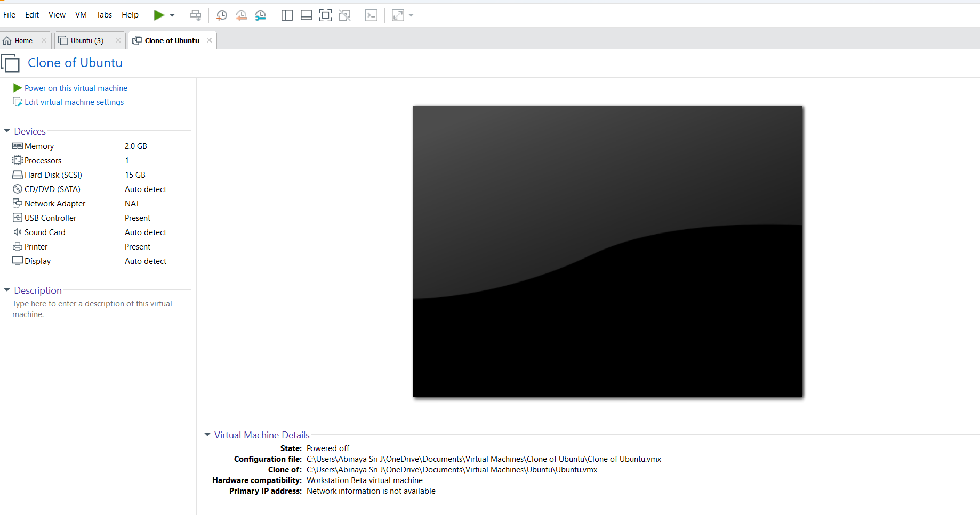
RESULT
The Virtual Machine was successfully cloned, and the cloned VM booted without errors. The operating system and applications loaded correctly, confirming that the cloning process was successful.

